Sunday | Monday | Tuesday | Wednesday | Thursday | Friday | Saturday
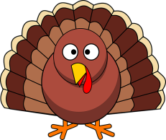
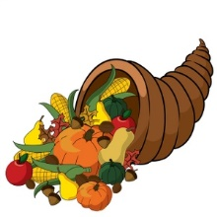
November 2020
Bluebirds Class I Mrs. Jarvis
M-F 9-1
1 | 2  Reviewing F, E, D and P  & numbers 1-5  this week | 3  Election  Day | 4  Snip, snip –  Reviewing and cutting shapes | 5  NO SCHOOL  Virtual teachers convention | 6  NO SCHOOL  Happy birthday  AMELIA! | 7
8 | 9  Letter Rr  #6 | 10  Guided drawing | 11  Making name rockets  3..2..1..  Blast off! | 12  Science experiment -hopping corn! | 13  Look for student update  in folder | 14
15 | 16  Bb for Bacon  Francis Bacon –our scientist of the month | 17  Number 7 | 18  Let’s be corny!  It’s Corn Day! | 19  Names and numbers | 20  Bubble fun! | 21
22 | 23 Happy  birthday  LAWRENCE and REAGAN! | 24  Let’s talk turkey!  Thanksgiving crafts | 25  Half Day  12pm  dismissal | 26  HAPPY  THANKSGIVING!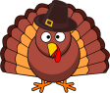  Gobble, gobble! | 27  NO SCHOOL | 28
29 | 30  Welcome back to school |  | 